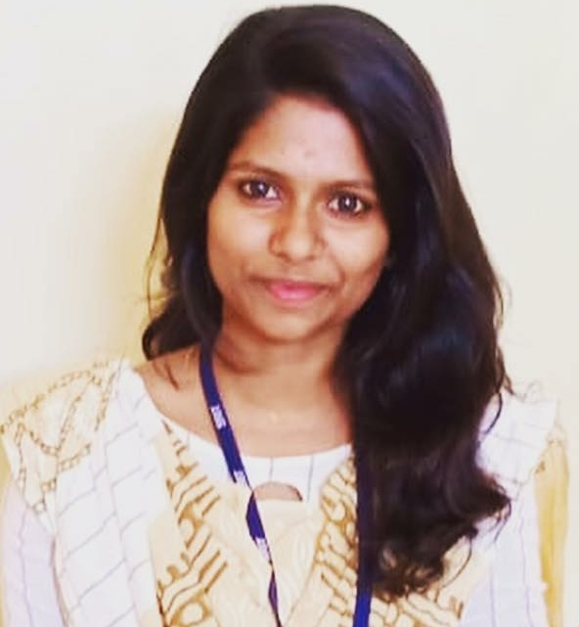

Passport size photograph
Candidate Information Form

GUIDELINES TO FILL FORM
- Use black ink to fill the form
- Please write in block letters

Personal Details

Full Name (as per govt id proof): NIVETHA VISWANATHAN
Date of Birth |  |  |  |  |  | 21-03-1998
Marrital Status |  |  |  |  |  | SINGLE
Spouse’s Name( If Married) |  |  |  |  |  | NA
If spouse is working, please indicate the profession |  |  |  |  |  |  |  |  | NA
If spouse is working with CGI, please mention |  |  |  |  |  |  |  | PSA ID |  |  | NA |  | Project Name |  |  |  | NA

Nationality: INDIAN
Current Location |  |  |  | KARAIKUDI |  |  |  |  | Preferred Job location |  |  |  |  |  | CHENNAI
Passport Details | Yes | YES |  |  | No |  |  | Passport number |  |  |  | S9619437 |  |  |  | Valid upto |  | 30/12/2028

PAN No: AZXPN5267C

Contact Details
Contact Number (Mobile) |  |  | 8526681105 |  |  |  |  |  |  | Contact Number (Landline) |  |  |  | NA
Email ID: GOUTHAMNIVE15@GMAIL.COM |  |  |  |  |  |  |  |  |  | Alternate Email ID: NA

Alternative Mobile Number (Family): 9865131312

Alternative Mobile Number (Friends): 9445994668

Academic Details (Please write in Block letters, please do not use short forms)
Particulars | Class X | Class XII / PUC | Graduation/ Engineering | Post-Graduation
Name of the degree | NA | NA | BACHELOR OF ENGINEERING | NA
Specialization/  Stream | NA | BIO-MATHS | COMPUTER SCIENCE ENGINEERING | NA
Name of the School/ College | MUTHIAH ALAGAPPA | VIDYA VIKAAS HIGHER SECONDARY SCHOOL | SRI RAMAKRISHNA INSTITUTE OF TECHNOLOGY | NA
Name of the University/Board | STATE BOARD | STATE BOARD | ANNA UNIVERSITY | NA
Year of passing | 2013 | 2015 | 2019 | NA
Percentage/Class  /CGPA | 94% | 88.9% | 6.9 | NA

NIVETHA VISWANATHAN
INTERVIEW DATE : 26-MAY-2021

Candidate Information Form

Name of the candidate | NIVETHA VISWANATHAN

Additional Courses / Certifications (If Any)
Certificate/Course Name | Specialization | College/Institution |  |  |  | Year of Passing |  | Percentage/Class
PROGRAMMING WITH JAVA | JAVA | SRI RAMAKRISHNA INSTITUTE OF TECHNOLOGY |  |  |  | 2019 |  | NA

Gaps / Breaks in Education (If any)
From Date | To Date |  | Degree / Course | Duration | Remarks / Reason for Gap
NA | NA |  | NA | NA | NA
Minimum time required to join (In Days) |  |  |  |  | 40 TO 60 DAYS
Have you been interviewed by CGI in last 6 months |  |  |  |  | YES |  |  |  | NO | NO

Employment History (In Chronological Order)
From Date | To Date |  |  | Duration (In Months) |  |  | Organization | Designation
25-JUN-2019 | STILL WORKING |  |  | 24 MONTHS |  |  | COGNIZANT TECHNOLOGY SOLUTIONS | PROGRAMMER ANALYST

Gaps / Breaks in Career (If any)
From Date |  | To Date | Duration (In Months) |  |  | Remarks / Reason for Gap
NA |  | NA | NA |  |  | NA
Total Experience (in months) |  |  |  |  | 24
Relevant Experience (in Yrs) |  |  |  |  | 2

I hereby declare that all information furnished here are true and correct to the best of my knowledge and belief.

Date: 06/09/2021 Signature: NIVETHA VISWANATHAN

NIVETHA VISWANATHAN
INTERVIEW DATE : 26-MAY-2021

